Spring Boot E-Library Web Application

(with Thymeleaf, Bootstrap 4, Spring MVC, Spring Data JPA, Hibernate, MySQL)

By Wia Handayani

1. This application manage 6 data (user, member, category, book, borrowing and returning data)
2. Database using MySQL and front-end using thymeleaf also bootstrap 4
3. The name of its database is **uts_pelatihan_wia**
4. This application can login with 2 kind of user (admin and member) but there are several menu that not appropiate cause i can’t find tutorial that match with my ability, maybe i can but it will take more time{sorry for my mistake hehe}
5. So here is how to use this application
6. When the application running, first you will se login window:

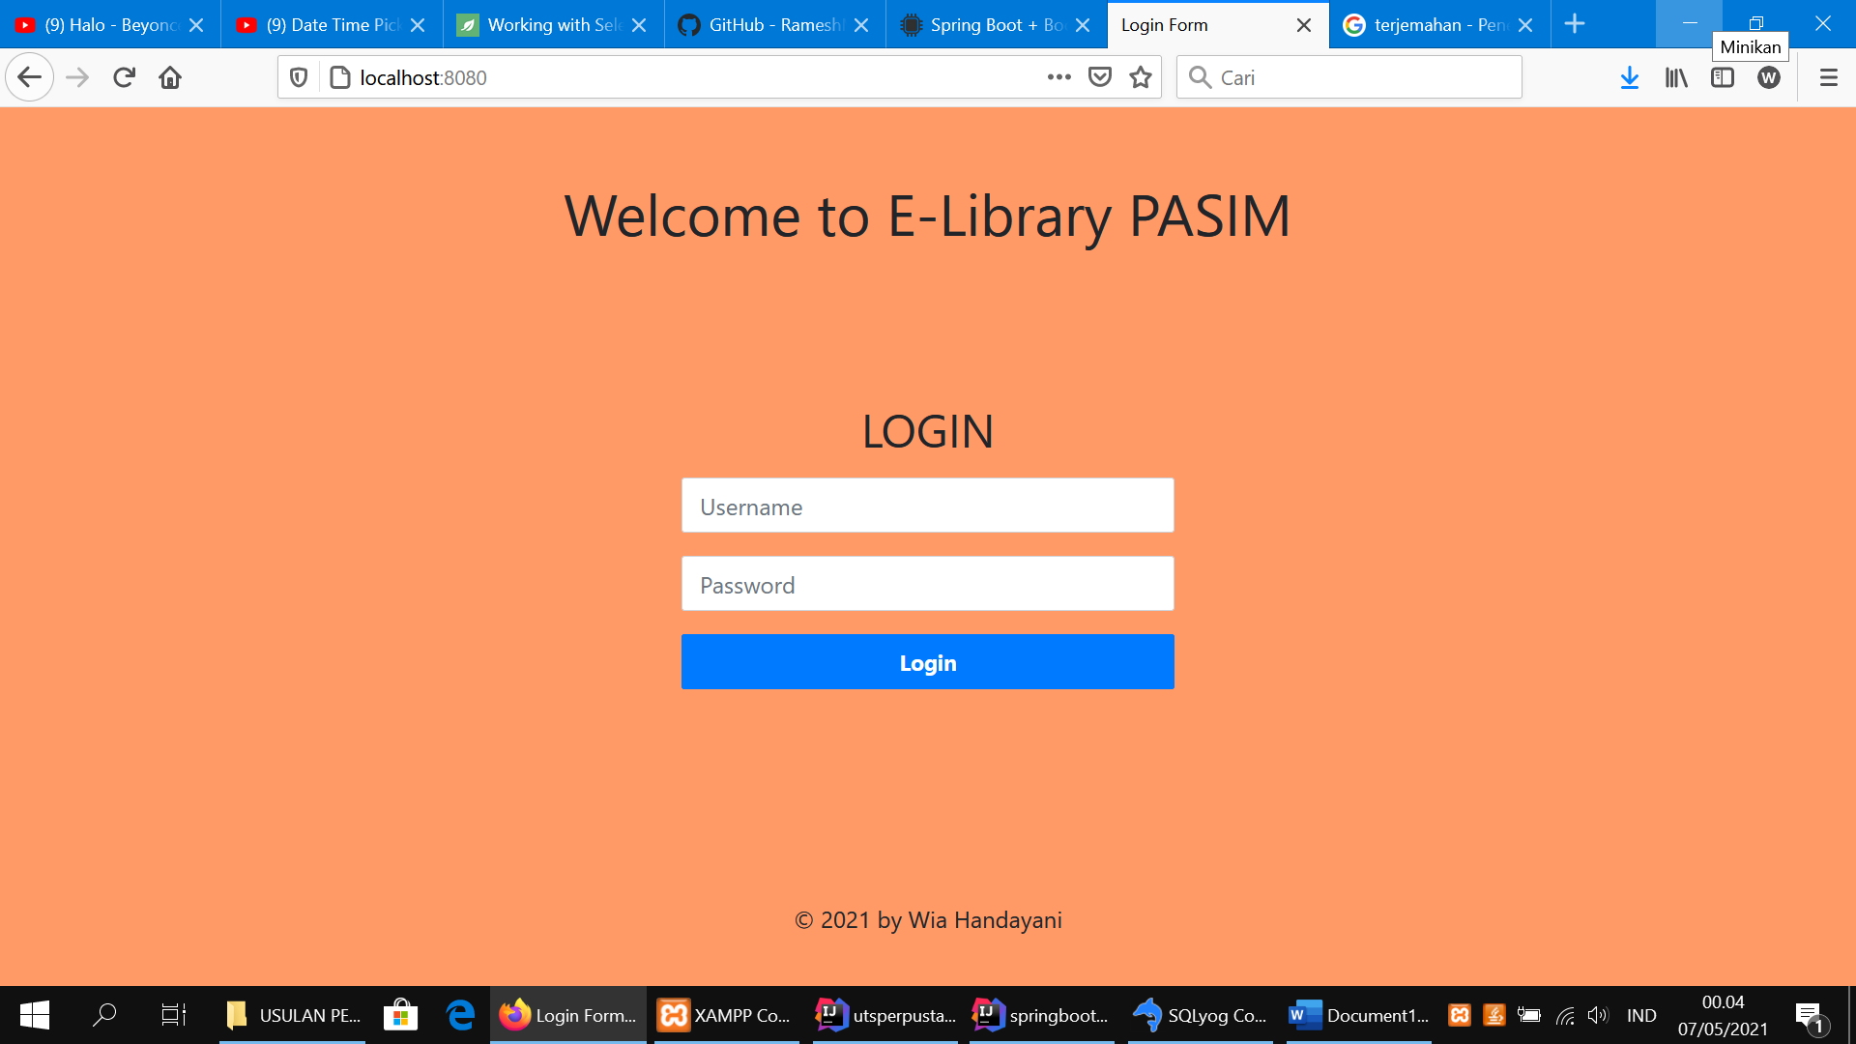

You have to input the username and password that already registered in database.

1. When you login as admin, the window will show:

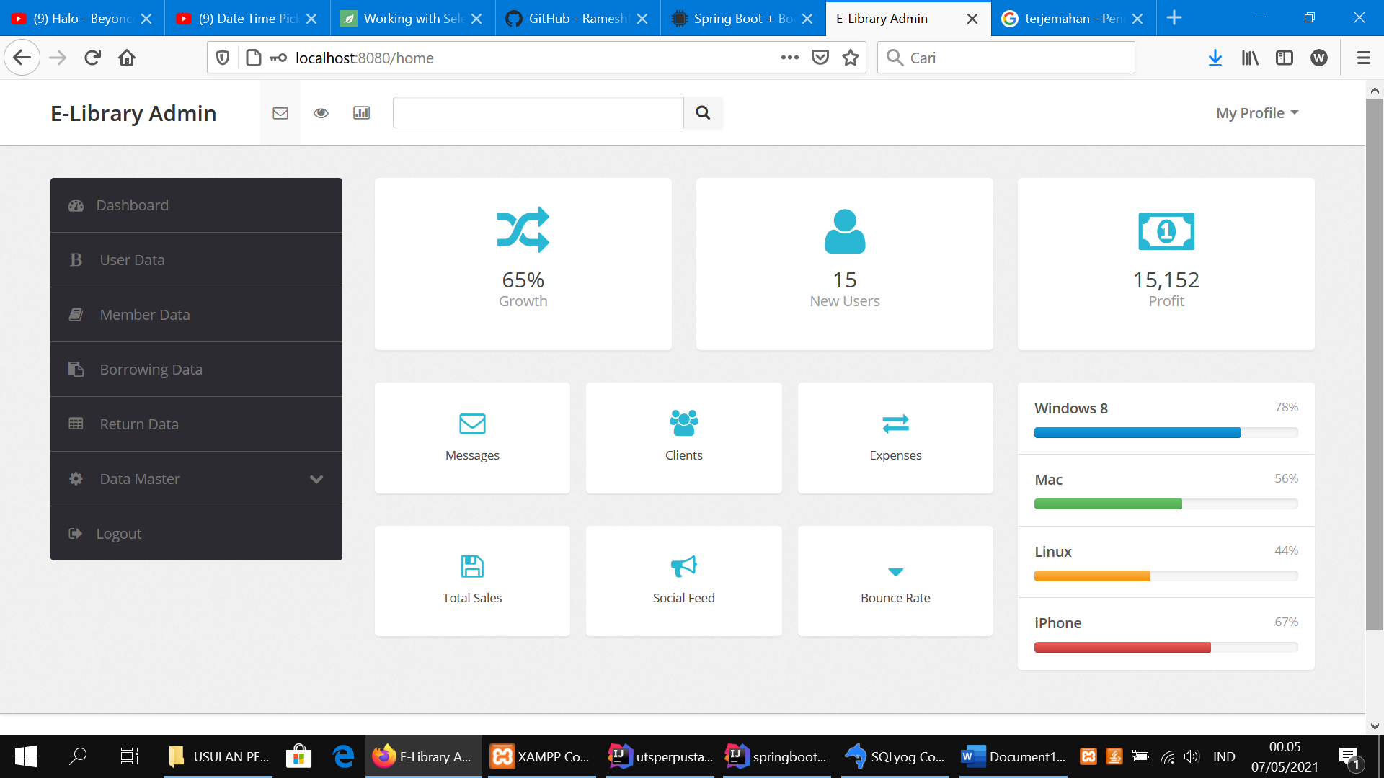

And when you login as member, the window will show:

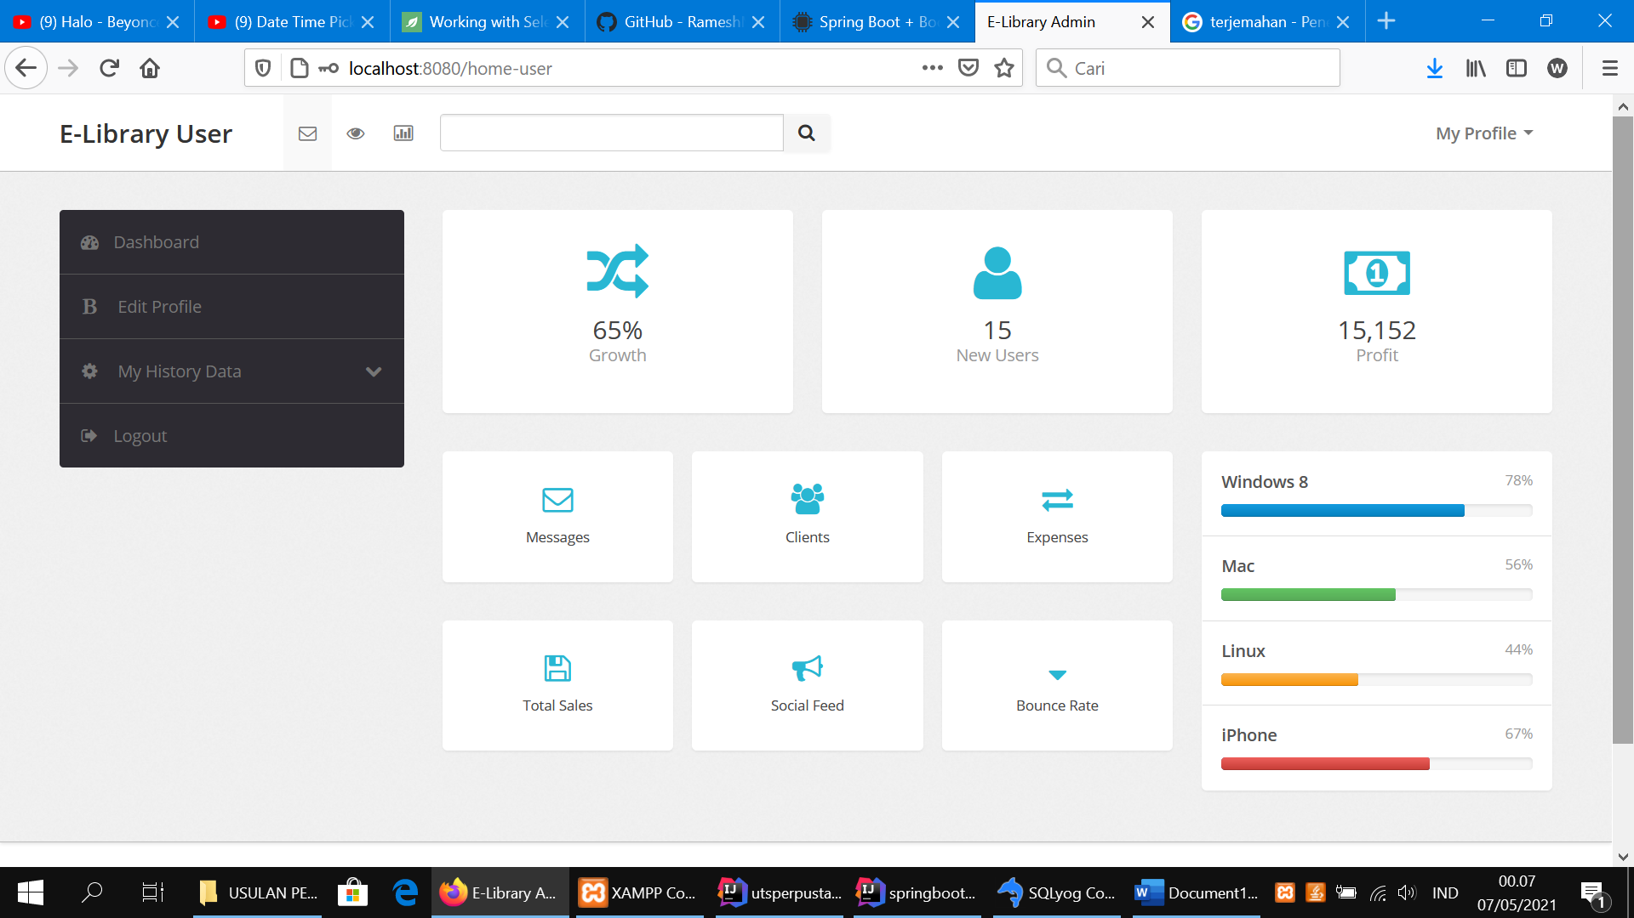

1. When you login as admin in every menu you can modify the data, both insert, update, delete or even find the data, in admin also there are 8 menu:
2. Dashboard
3. User Data

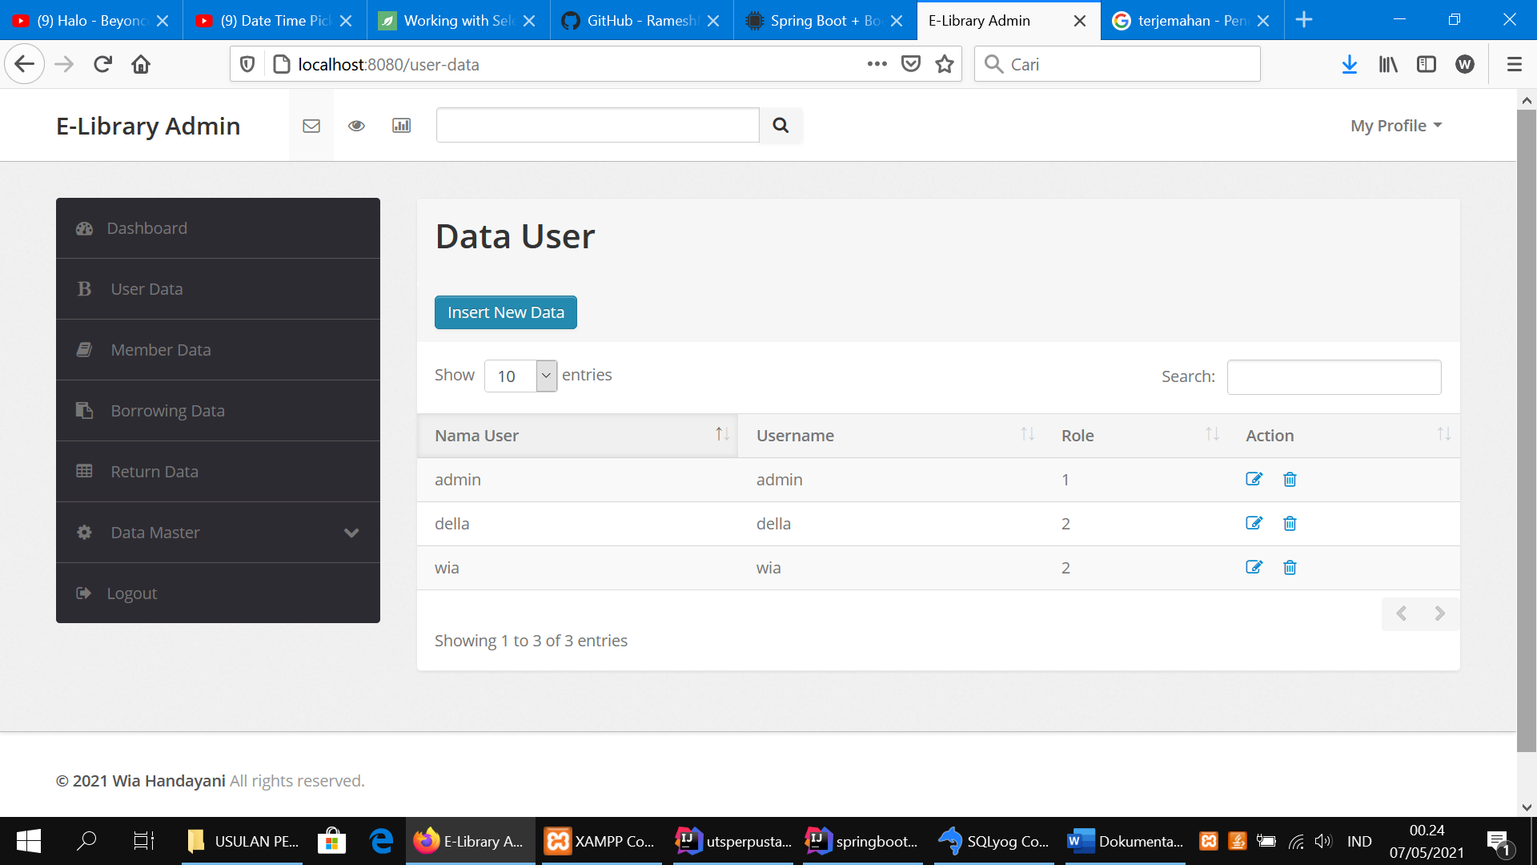

1. Member Data

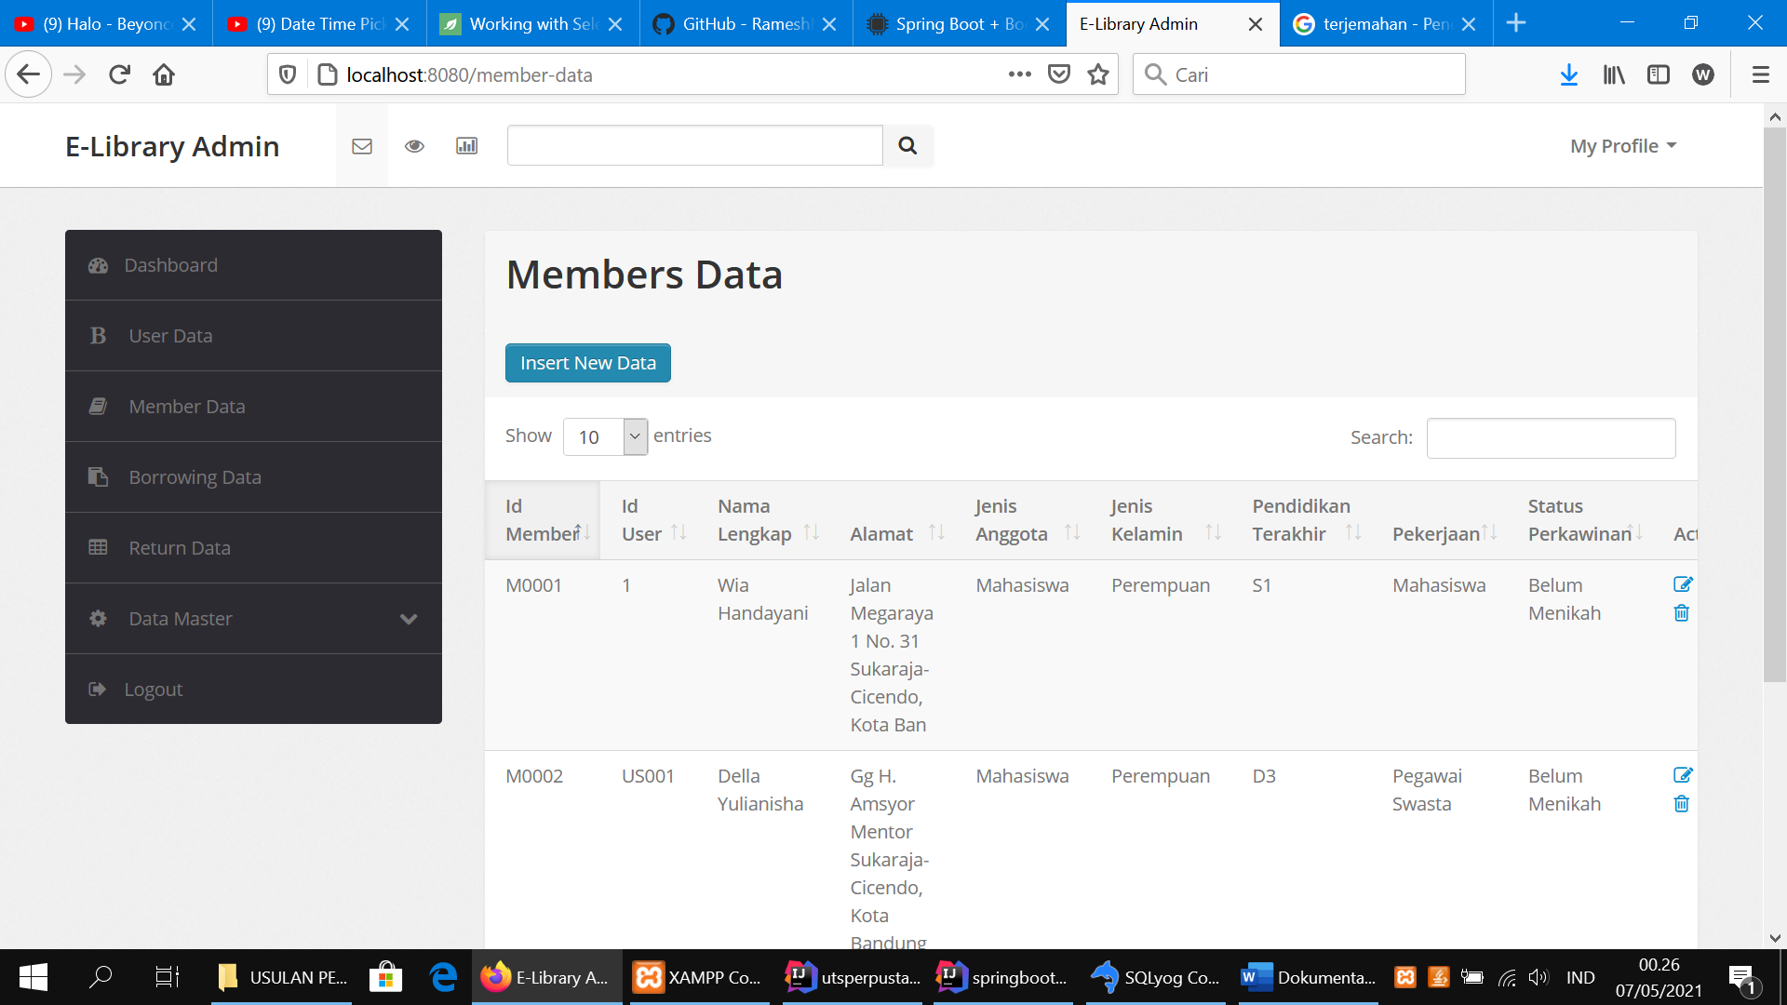

1. Borrowing Data

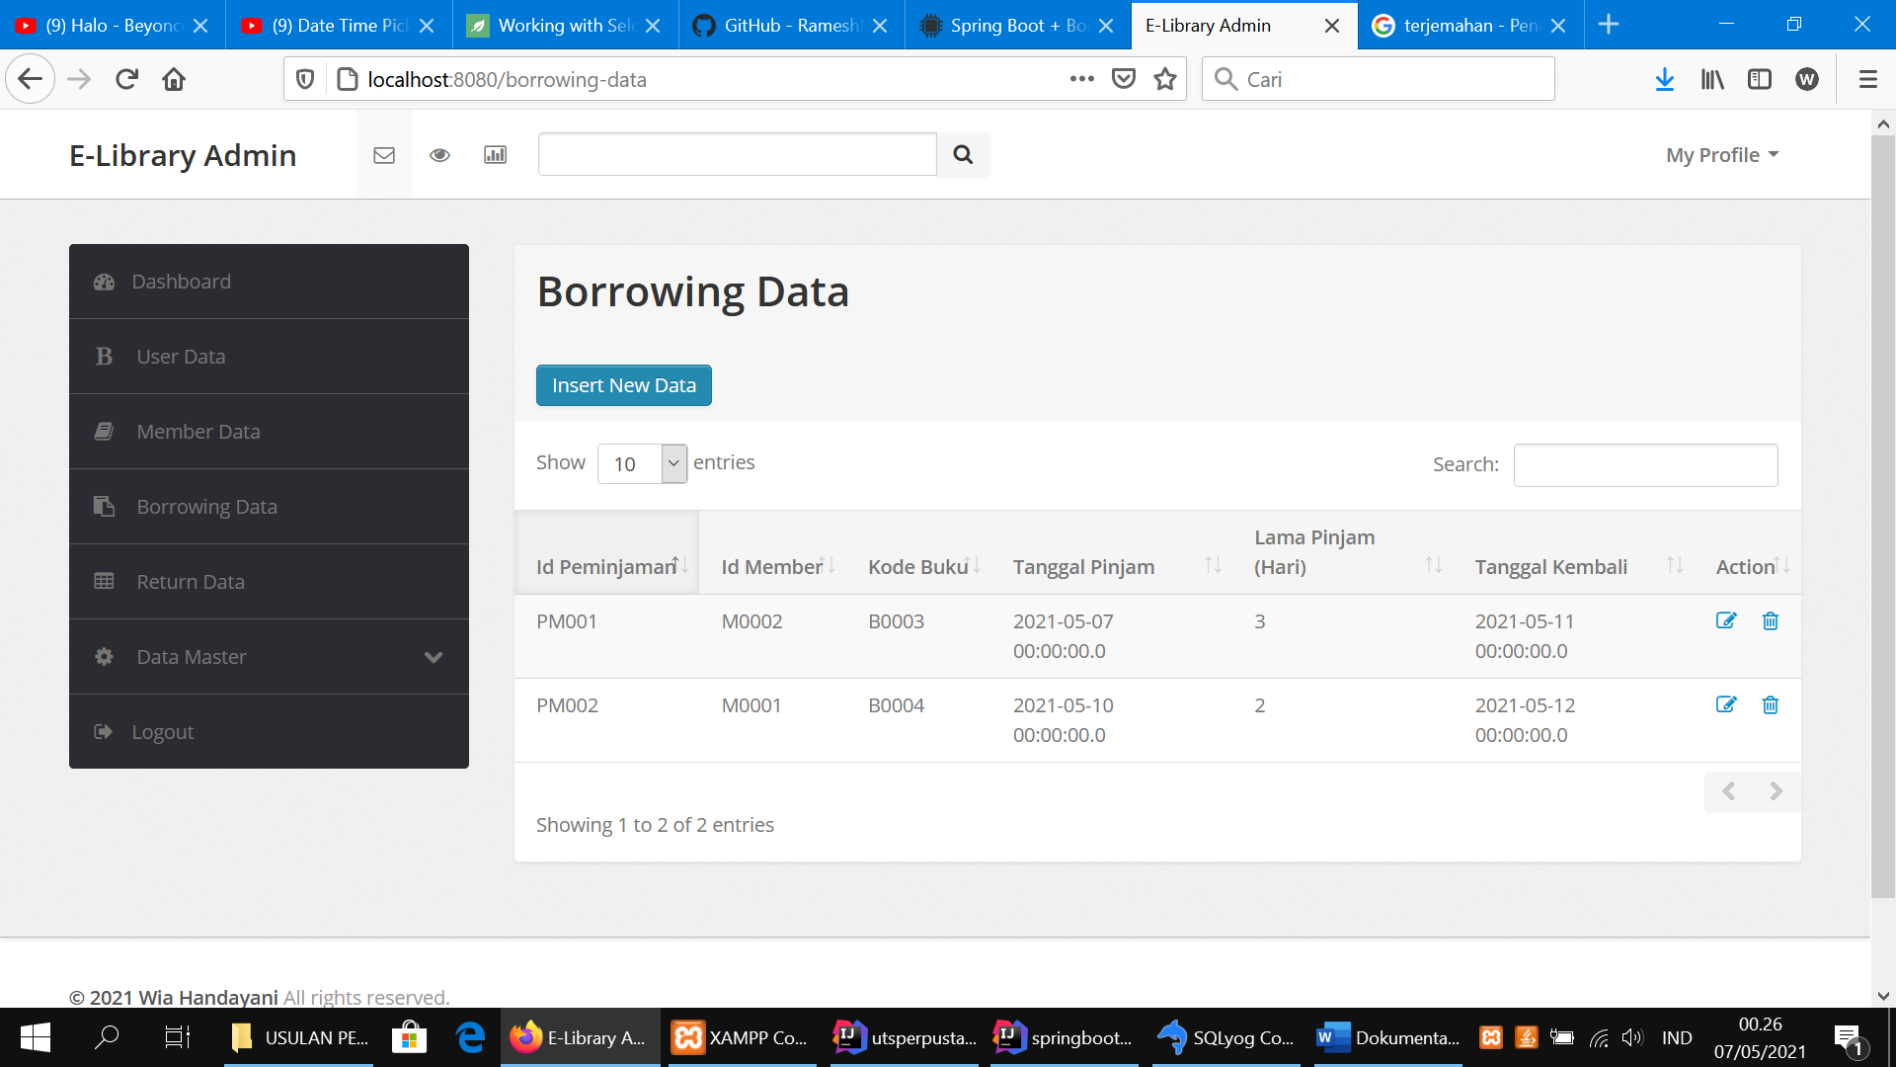

1. Returning Data

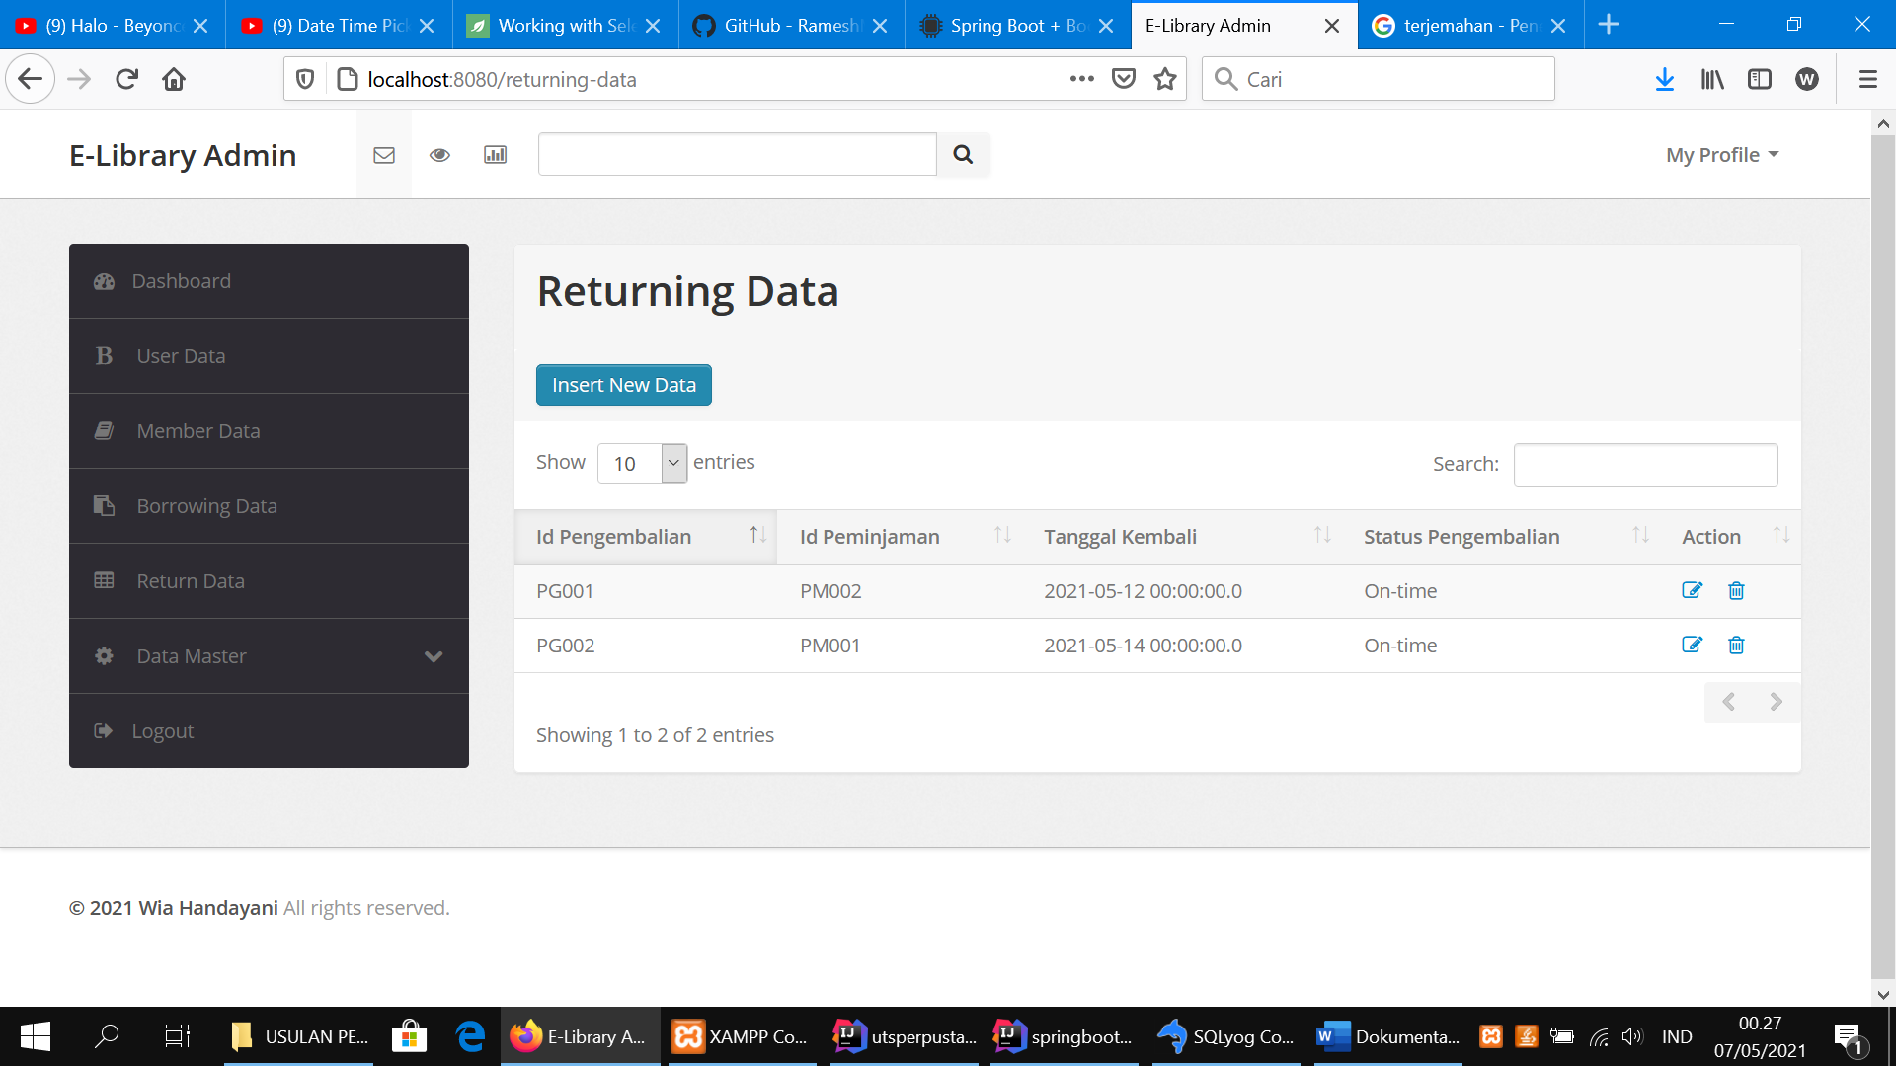

1. Master Data (there are 2 menu in master data, Category Data and Books Data)

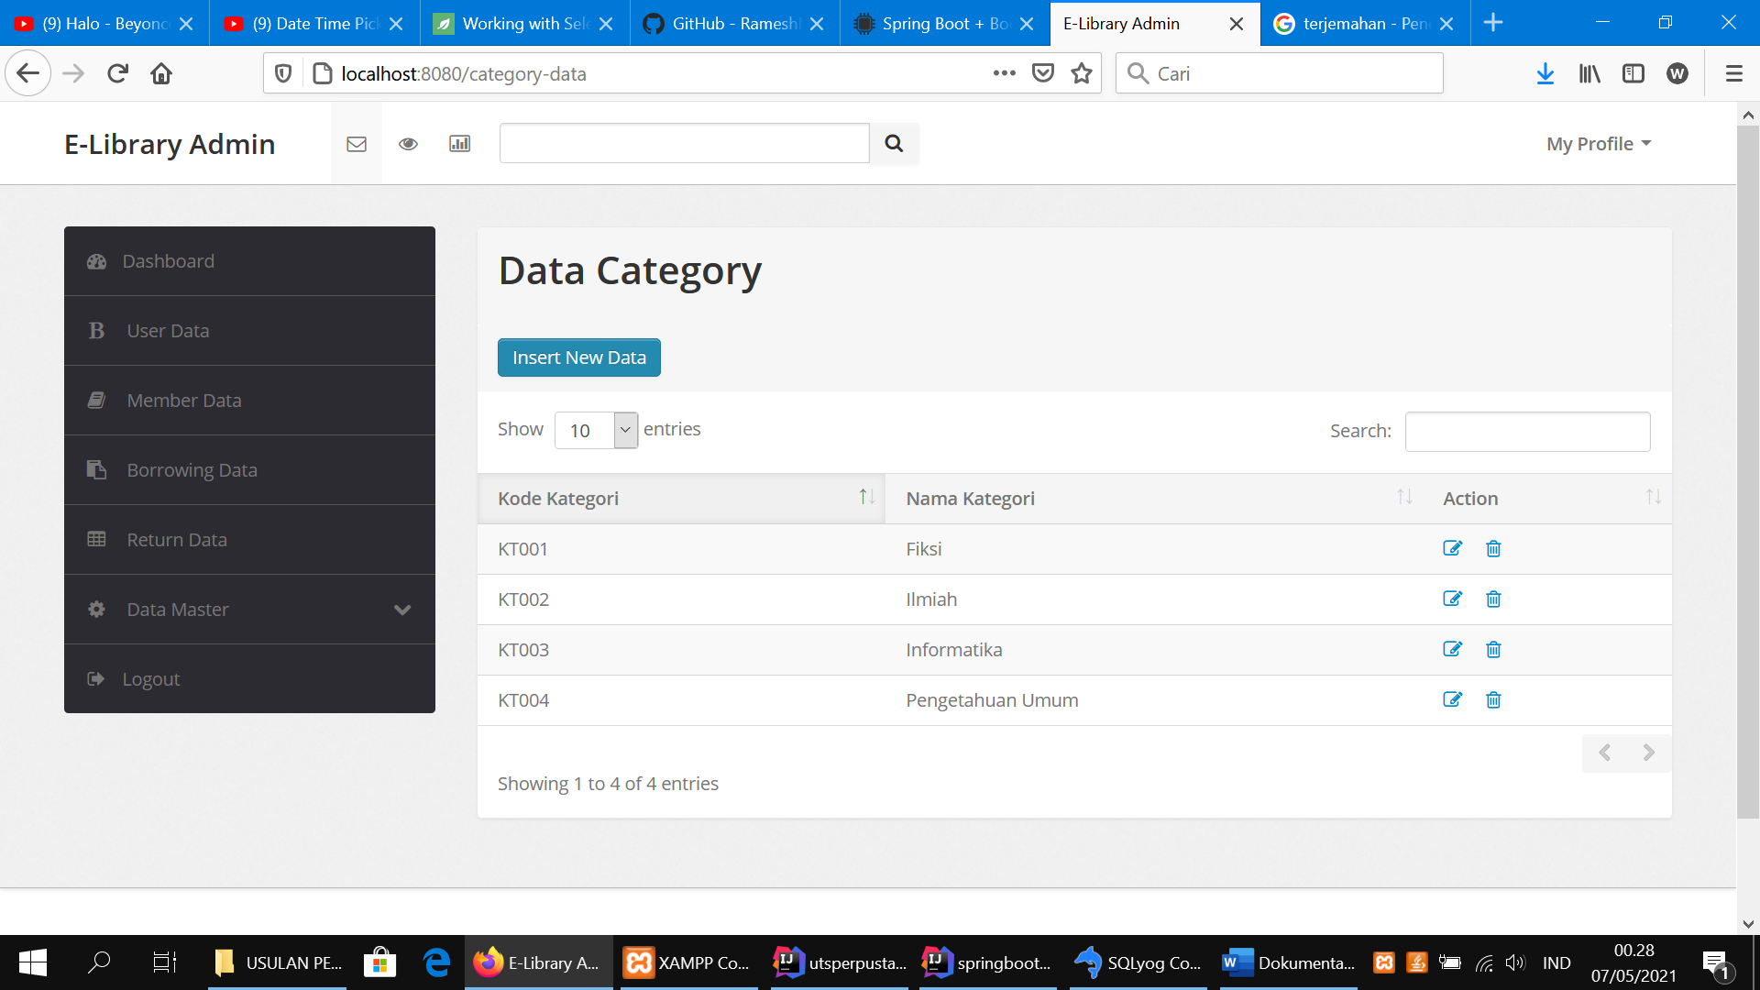

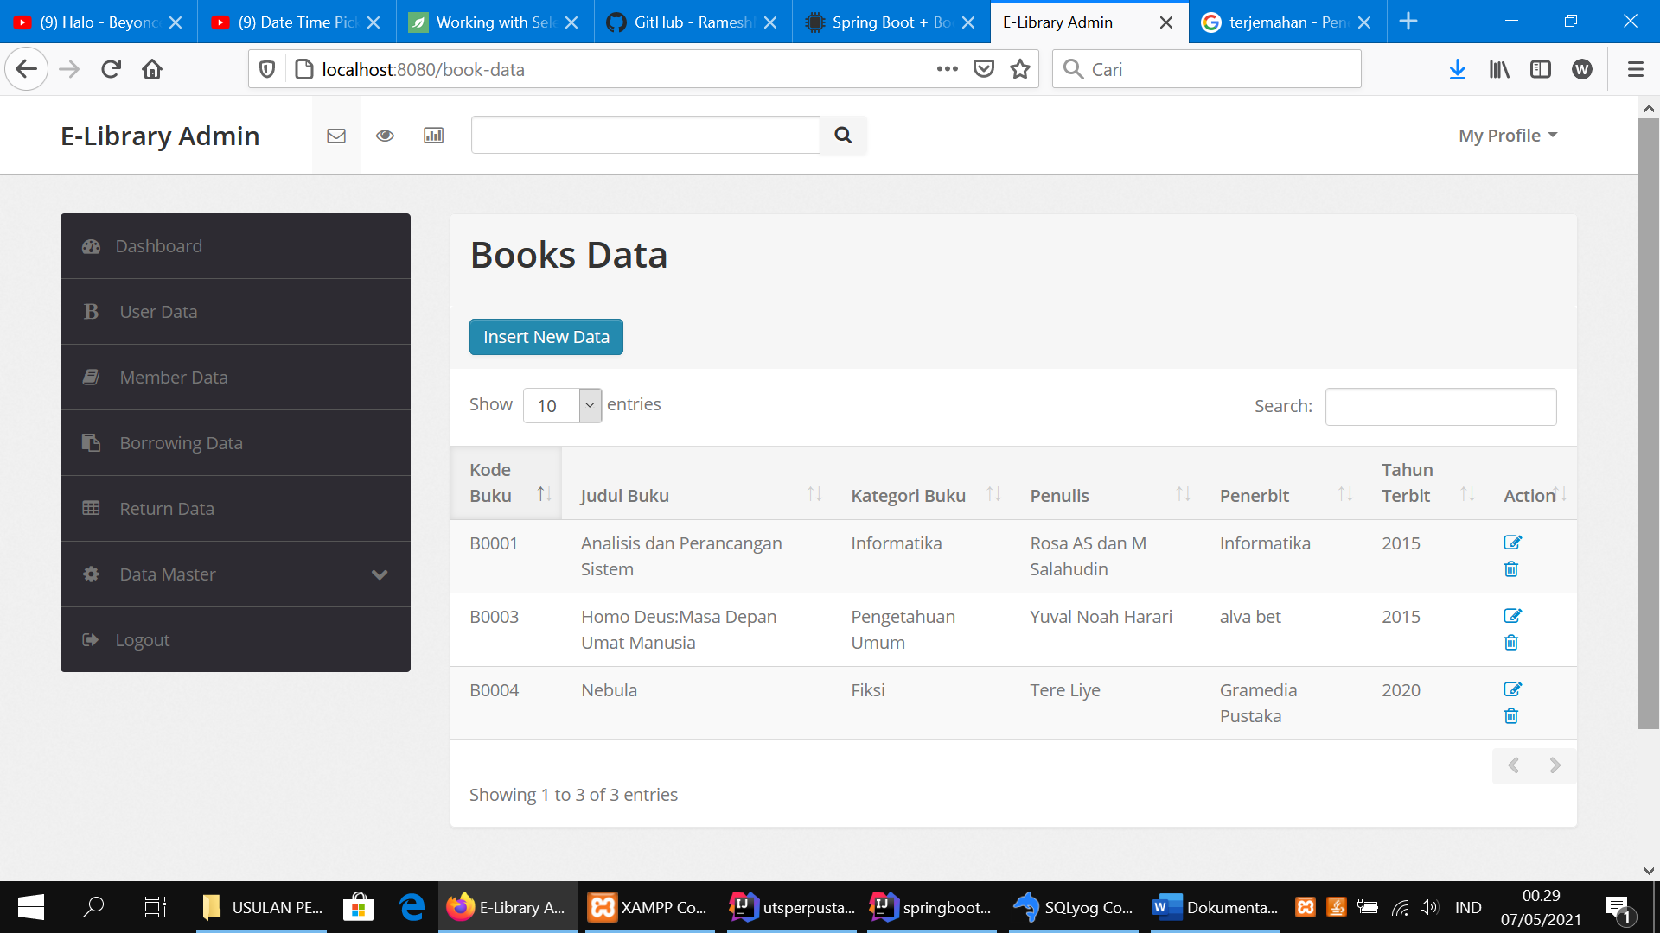

{For member menu, the display still in progress a.k.a udah mentok karena ga keburu, harus bagi2 waktu buat yg lain juga hehe, i hope you guys both teh ilfa and a sandi will enjoy the apps and appreciate it! Thank you for teaching us especially me 😊 }